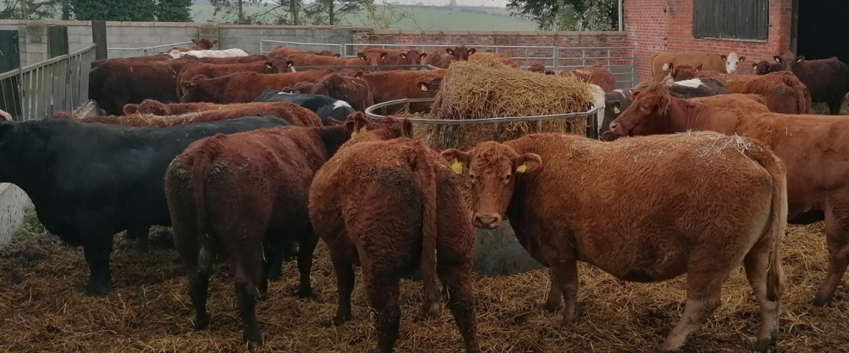

**85 IN-CALF COWS**

**15 IN-CALF HEIFERS**

**11 COWS IN CALF WITH CALVES AT FOOT**

**4 LIMOUSIN & CHAROLAIS STOCK BULLS**

**TB4, BVD VACCINATED**

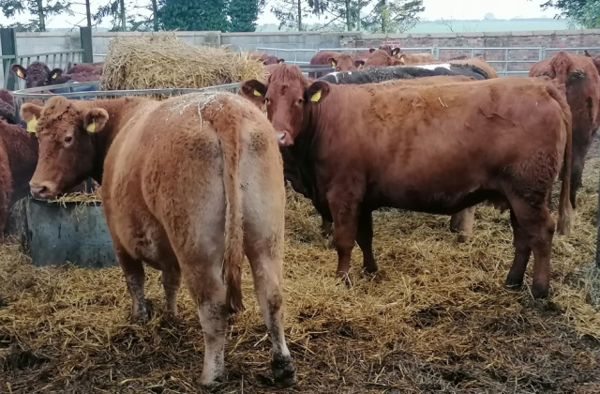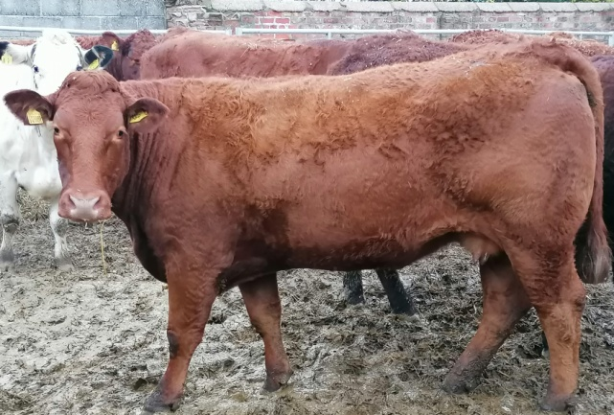

ENQUIRES TO:

Richard Haigh (Auctioneer): 07768 594535

Market Office, Bawtry Road, Selby YO8 8NB

01757 703347

Email: [info@selbymart.co.uk](mailto:info@selbymart.co.uk)

www.selbymart.co.uk